AWS LAMBDA EXECUTION
- Go to aws console and login to your account
- Search aws lambda create function

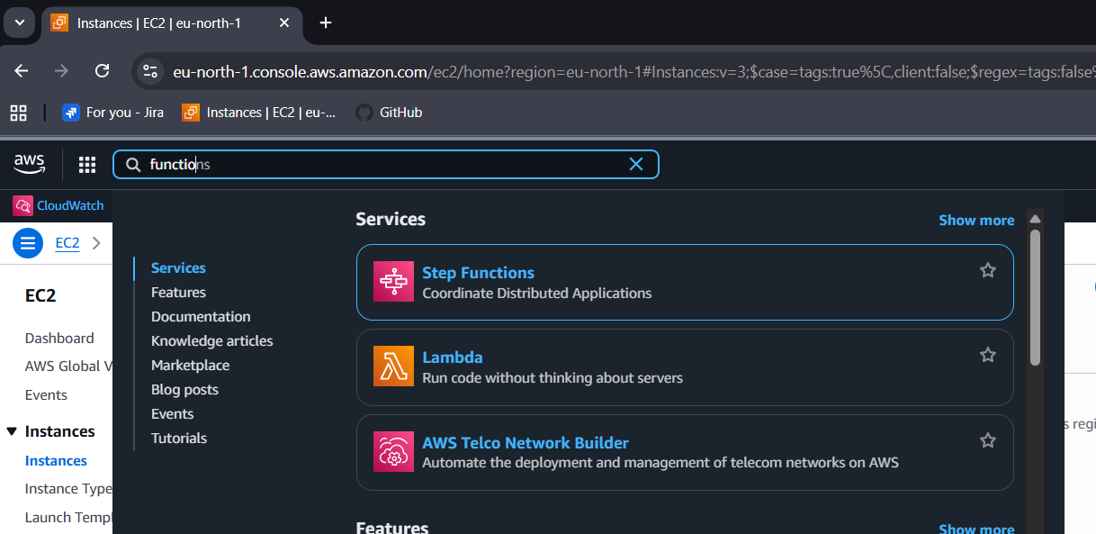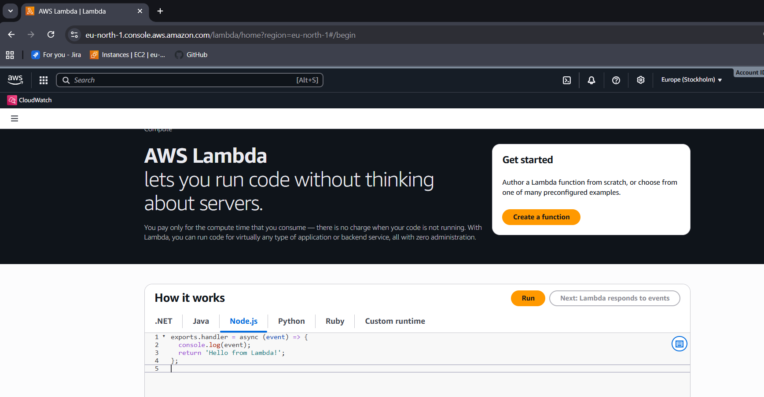

- Select Author from scratch
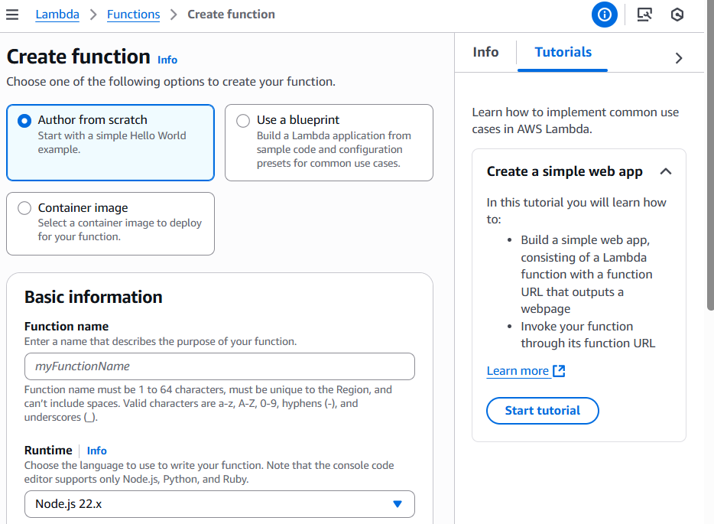
- In the Basic information pane, for Function name, enter myLambdaFunction.
- For Runtime, choose either Node.js 22 or Python 3.13.

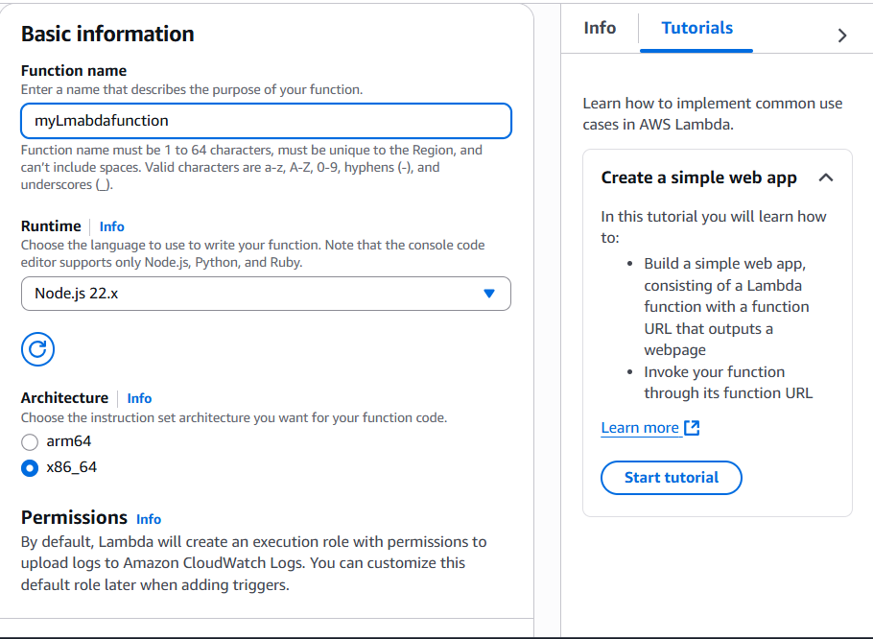
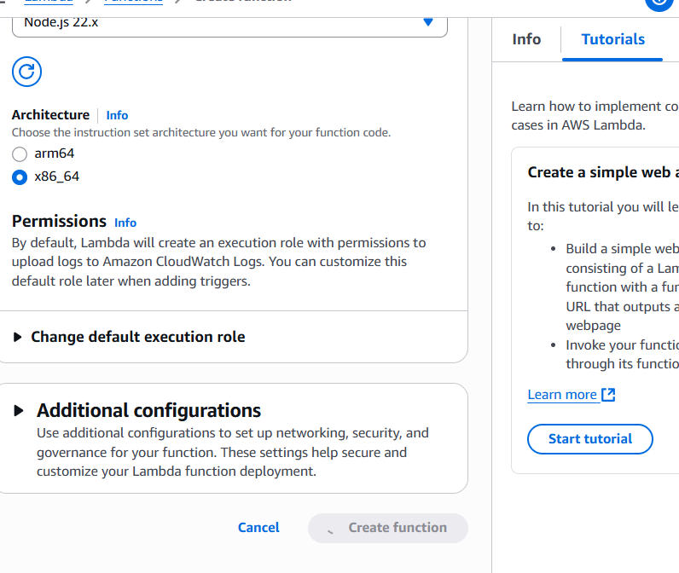
- After creation replace the code in index.mjs
export const handler = async (event, context) => {

const length = event.length;
const width = event.width;
let area = calculateArea(length, width);
console.log(`The area is ${area}`);

console.log('CloudWatch log group: ', context.logGroupName);

let data = {
"area": area,
};
return JSON.stringify(data);

function calculateArea(length, width) {
return length * width;
}
};
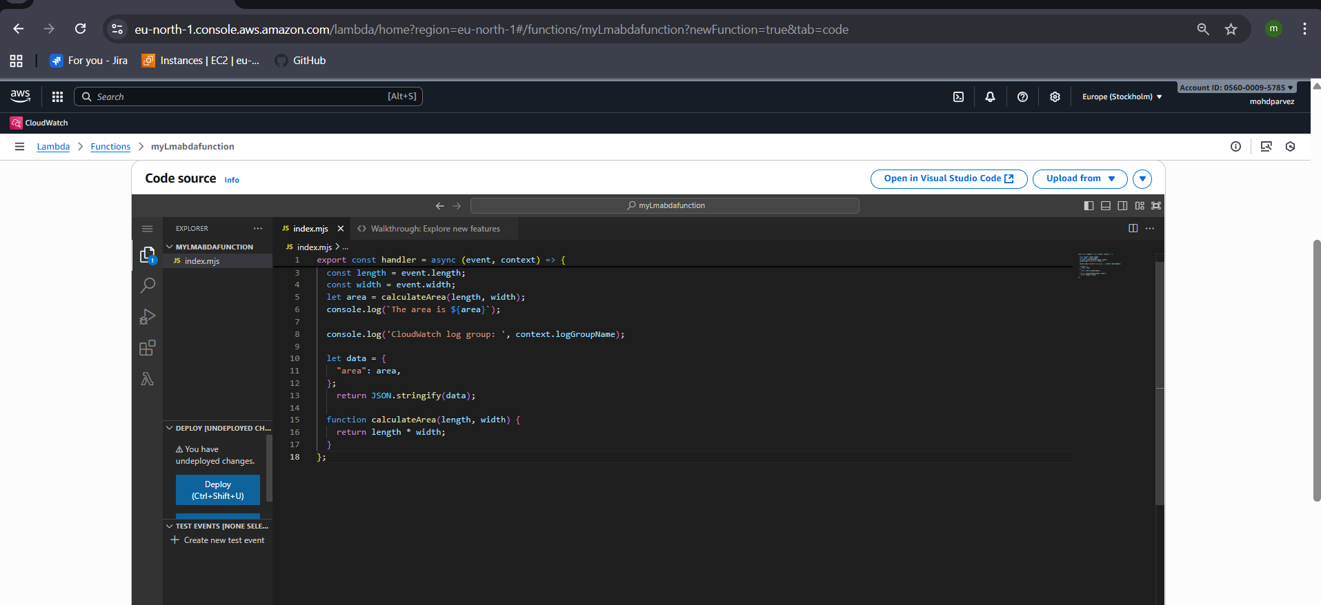

- Click on test
- Select the popup option create new test event
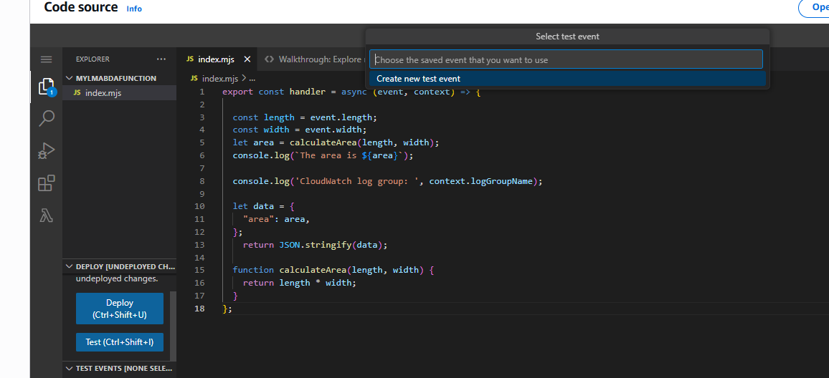
- For event you have created ,enter name :mytestevent
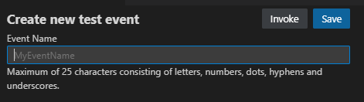
- In the Event JSON section, replace the default JSON with the following:
{
"length": 6,
"width": 7
}
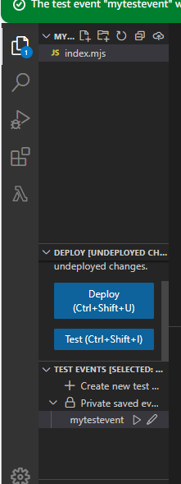
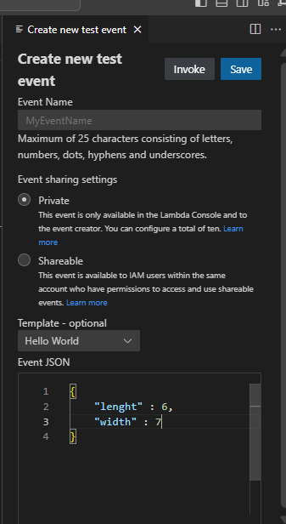
- save the event and run the event and check the output

- Here you can see your event is is succeeded or failed and also problems ,code reference log
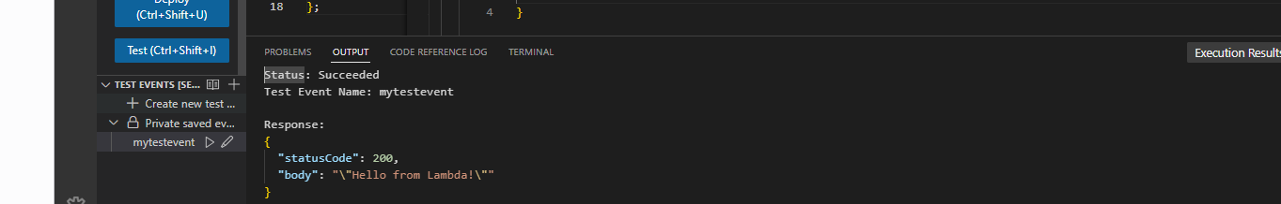

To view your function's invocation records in CloudWatch Logs
- Open the log groups page of the CloudWatch console.
- Choose the log group for your function (/aws/lambda/myLambdaFunction). This is the log group name that your function printed to the console.
- Scroll down and choose the Log stream for the function invocations you want to look at.
